02.22 SUBORDINATION AGREEMENT WORK PROGRAM

The following describes the functionality and features included in Probe Audit Premium+

Objective

The objective of this document is to guide the engagement team through the audit procedures required to evaluate the validity, compliance, and adequacy of subordination agreements or letters of comfort / support obtained by the entity.

The following key concepts of the Probe Audit Premium+ Methodology are set in this document:
- Validity and enforceability of subordination agreements supporting going concern (ISA 570)
- Assessment of whether subordinated amounts are sufficient to restore commercial solvency
- Direct linkage of subordination agreement findings to the going concern conclusion in document 02.20

Document placement

Document 02.22 – Subordination agreement work program can be found in the Finalisation folder in the Caseware document manager.
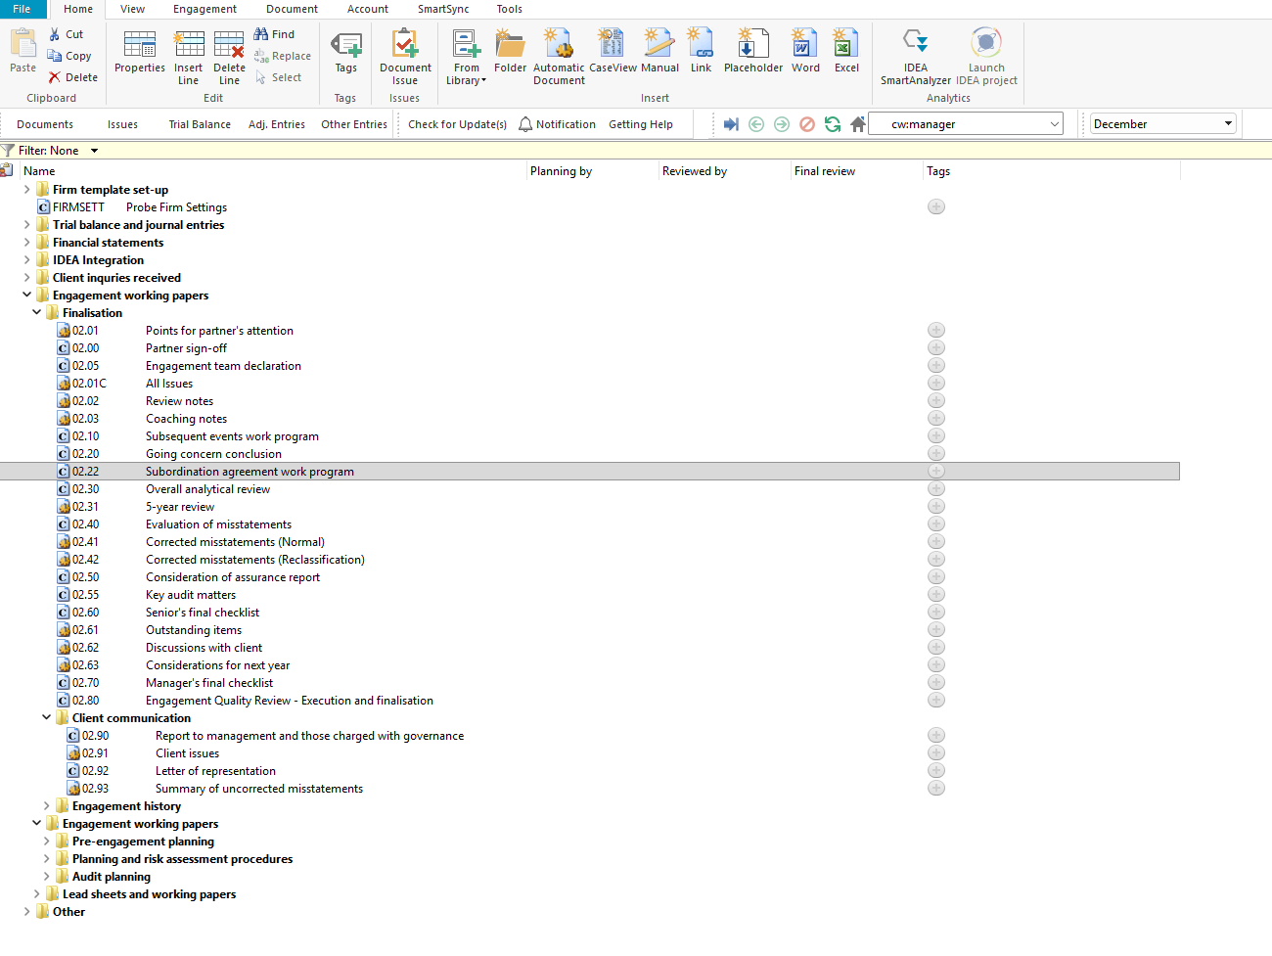

Document content

This document is designed to be a CaseView work program with pre-populated audit procedures for evaluating subordination agreements or letters of comfort / support. The work program includes space for documenting exceptions, the person who performed the procedure, and cross-references.

This document addresses ISA 570 (Going Concern) and ISA 250 (Consideration of Laws and Regulations in an Audit of Financial Statements) by providing a structured set of procedures for evaluating the validity, enforceability, and compliance of subordination agreements, and assessing the impact on the entity's going concern assessment and financial statement disclosures.

This document is divided into different bookmarks in the document map to assist you with navigation:

Audit procedures

Conclusion
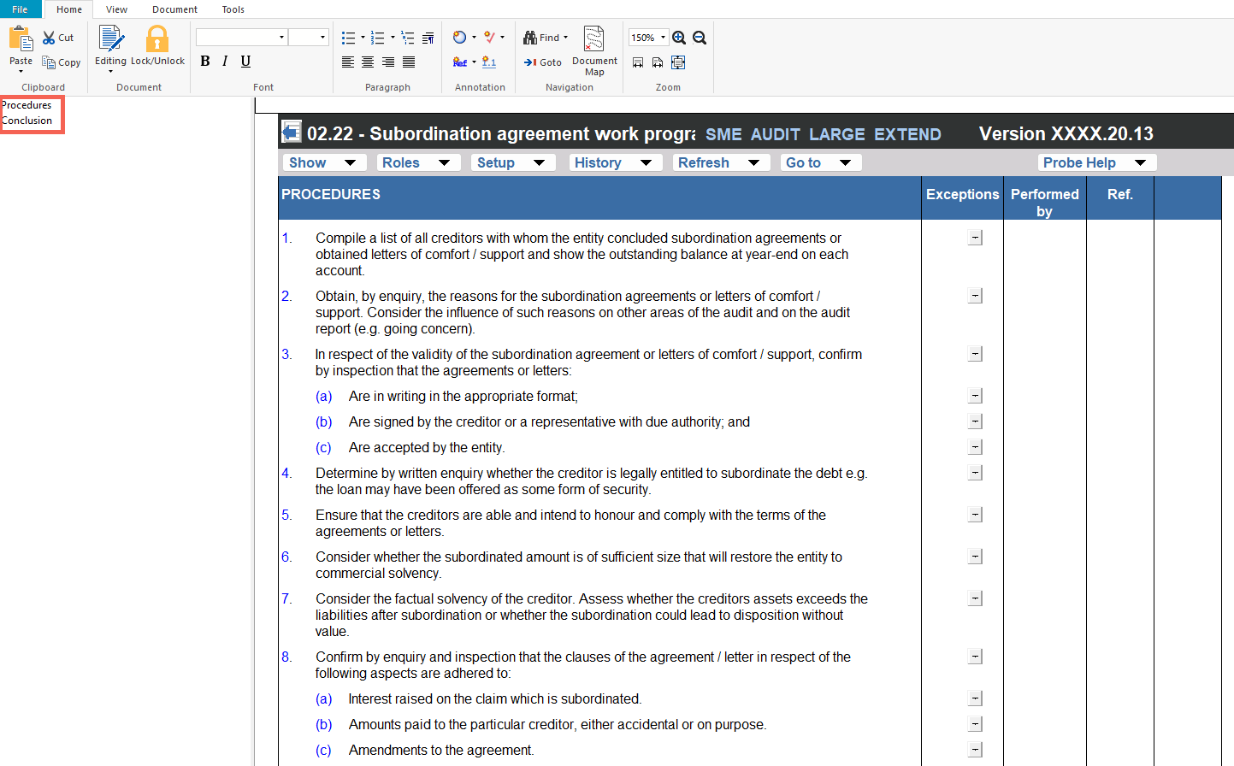

Layout
Column | Input Required | Outcome
Audit procedures
Audit procedures | No input is required in this column. Displays 13 numbered audit procedures for evaluating subordination agreements or letters of comfort / support. The procedures address compiling a list of all creditors, obtaining reasons for subordination, validating the agreements, determining legal entitlement, assessing creditor solvency, confirming compliance with agreement clauses, evaluating non-resident creditor requirements, and confirming adequate financial statement disclosure. | No impact on the engagement file. Provides the structured work program for the engagement team to evaluate subordination agreements.
Exceptions | Enter any exceptions or findings identified during the performance of each audit procedure. | No impact on the engagement file. Documents the exceptions identified for the engagement file.
Performed by | Enter the name or initials of the engagement team member who performed the procedure. | No impact on the engagement file. Records the person who performed each procedure for the engagement file.
Ref. | Enter a cross-reference to the relevant working paper or supporting documentation for each procedure. | No impact on the engagement file. Documents the cross-reference for the engagement file.
Conclusion
Conclusion questions | No input is required in this column. Displays three pre-populated conclusion questions addressing: (1) whether the results indicate non-compliance with a subordination agreement, (2) whether the company is continuing to trade without reasonable expectation of meeting its liabilities and whether this is likely to cause financial loss, and (3) whether the existence of the agreement did not justify the adoption of a going concern basis of accounting. | No impact on the engagement file. Provides the conclusion framework for the engagement team's evaluation of the subordination agreement procedures.
Exceptions | Enter any exceptions or findings relating to each conclusion question. | No impact on the engagement file. Documents the engagement team's exceptions for each conclusion question.
Performed by | Enter the name or initials of the engagement team member who evaluated each conclusion question. | No impact on the engagement file. Records the person who evaluated each conclusion question for the engagement file.
Ref. | Enter a cross-reference to the relevant working paper or supporting documentation for each conclusion question. | No impact on the engagement file. Documents the cross-reference for the engagement file.

Document outcomes

The engagement team must perform the 13 audit procedures and document their exceptions, the person who performed each procedure, and cross-references. The procedures cover compiling creditor lists, obtaining reasons for subordination, validating the agreements, determining legal entitlement, assessing creditor ability to honour terms, evaluating the adequacy of the subordinated amount, assessing creditor solvency, confirming compliance with agreement clauses, evaluating non-resident creditor requirements, ensuring the agreement is on file, and confirming adequate financial statement disclosure.

The engagement team must evaluate the three conclusion questions to determine whether the results of the procedures indicate non-compliance with a subordination agreement, whether the company is continuing to trade without reasonable expectation of meeting its liabilities, and whether the existence of the agreement justifies the adoption of a going concern basis of accounting.

Group Audits

When the engagement type was selected as 'Group Audit Single' or 'Group Audit Multiple', the subordination agreement work program applies to the group engagement. The engagement team must evaluate subordination agreements at both the group and component level and consider the impact on the group's going concern assessment.

IN CONCLUSION

Features

The following features are available in the document:

Insert or delete a comment, see page F3

Guidance, see page F16

Freeze, see page F19

